# Workshop 7 - Week 10 - CSY2085 – Server Administration and Security

## Workshop: Linux DNS and Web Server

STUDENT NAME: Muhammad Raza

STUDENT NUMBER: 21624838

## Task 1 - Preparing the Ubuntu Linux Server

1. Type in the following commands to check if the firewall rules have been applied correctly

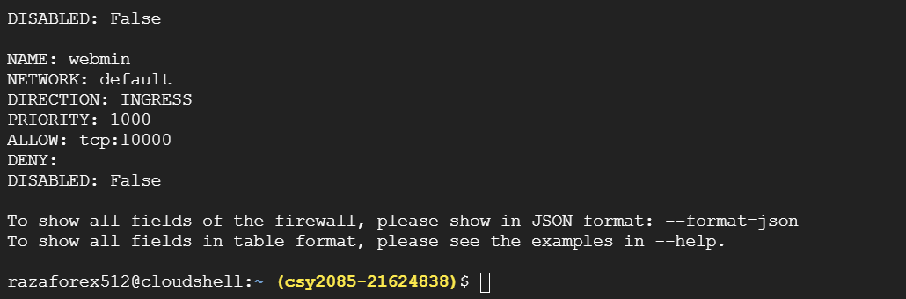

## Task 2 - Install Webmin on your server

1. Next, find out what your Linux Server Public IP address and record it below:  
   34.68.26.253
2. You should see a page like the following:

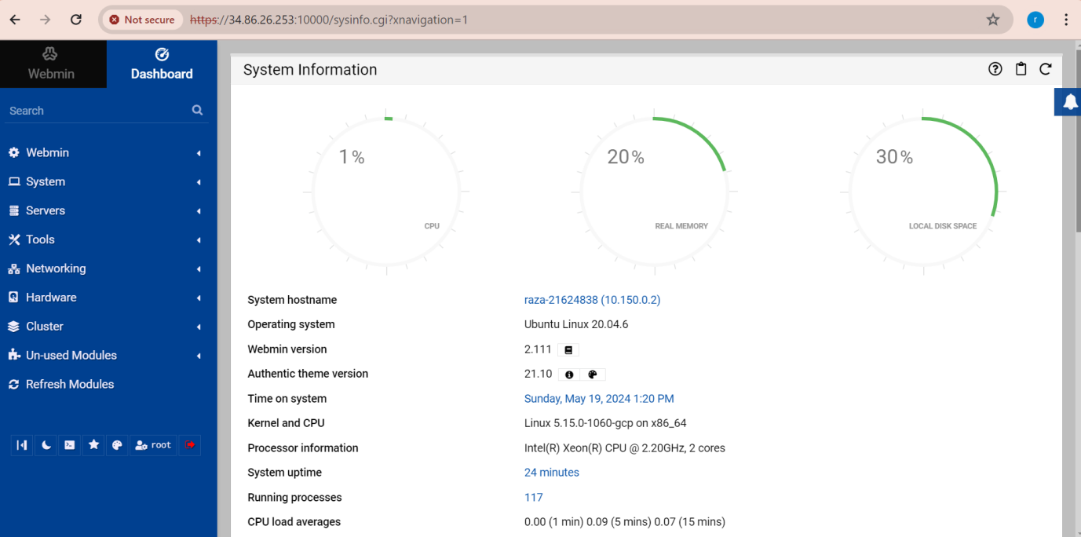

## Task 3 - Install Linux, Apache, MySQL, PHP (LAMP) stack on your server

1. You will see the default Apache web page, which is there for informational and testing purposes. It should look something like this:

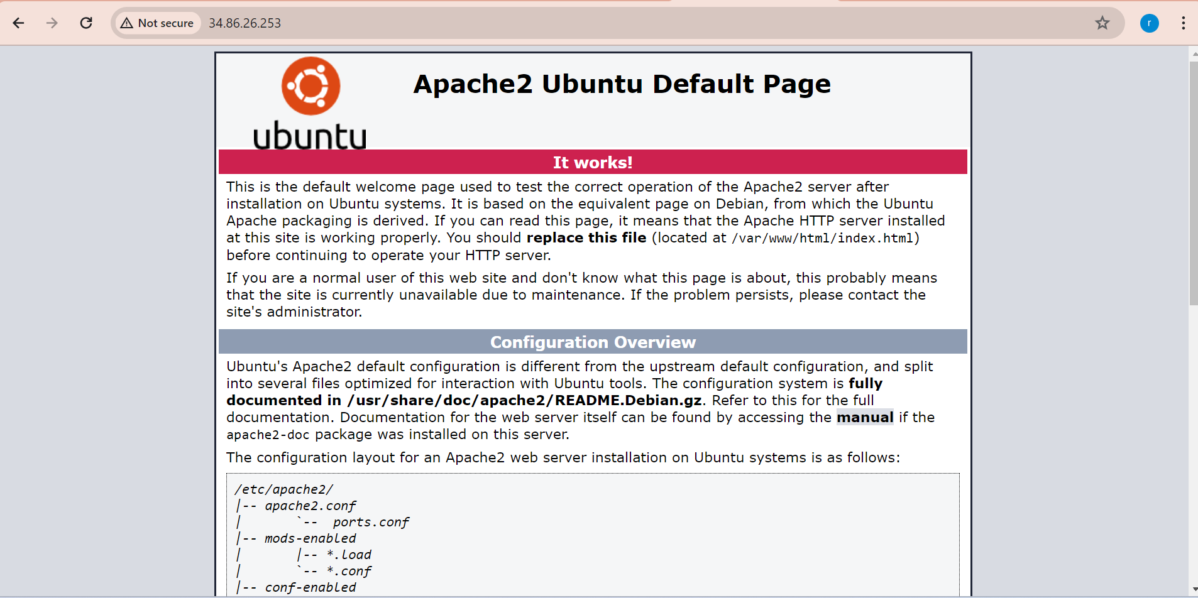

## Install BIND on your server.

**service bind9 status**

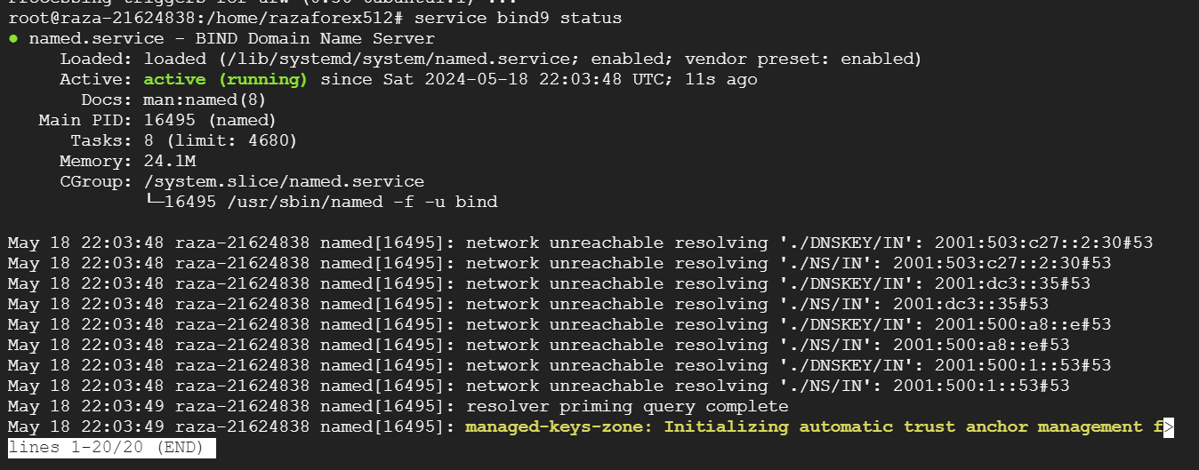

## Task 4- Preparing the Windows Client

1. When it is done, Webmin will show you the list of users including the new one that you have just created. Scroll towards the bottom of this page until it shows the new "testuser" details and capture the screen and paste it below:  
     
   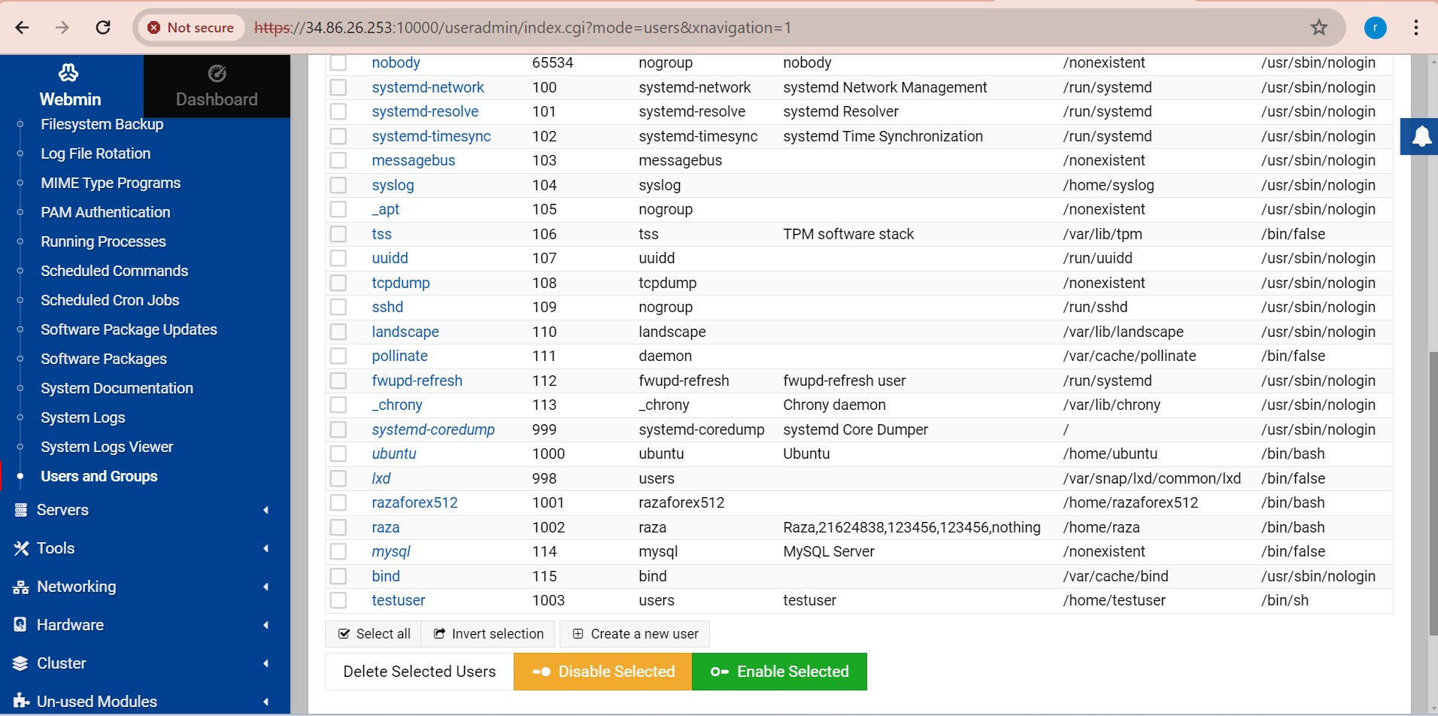

## Task 5 - Setting up the Apache Web Server

1. On the left-hand side of Webmin, click on Servers. Apache, MySQL and DNS servers should figure on the list. If not click on “Refresh Modules” at the bottom of the list to refresh these modules. Then reload webmin. Click on Apache Webserver. You will see the following screen:

## 7 apache webserver

## Task 6 - Setting up the Domain Name Service on the Linux Server

1. Capture your version of the above screen and paste it below:  
     
   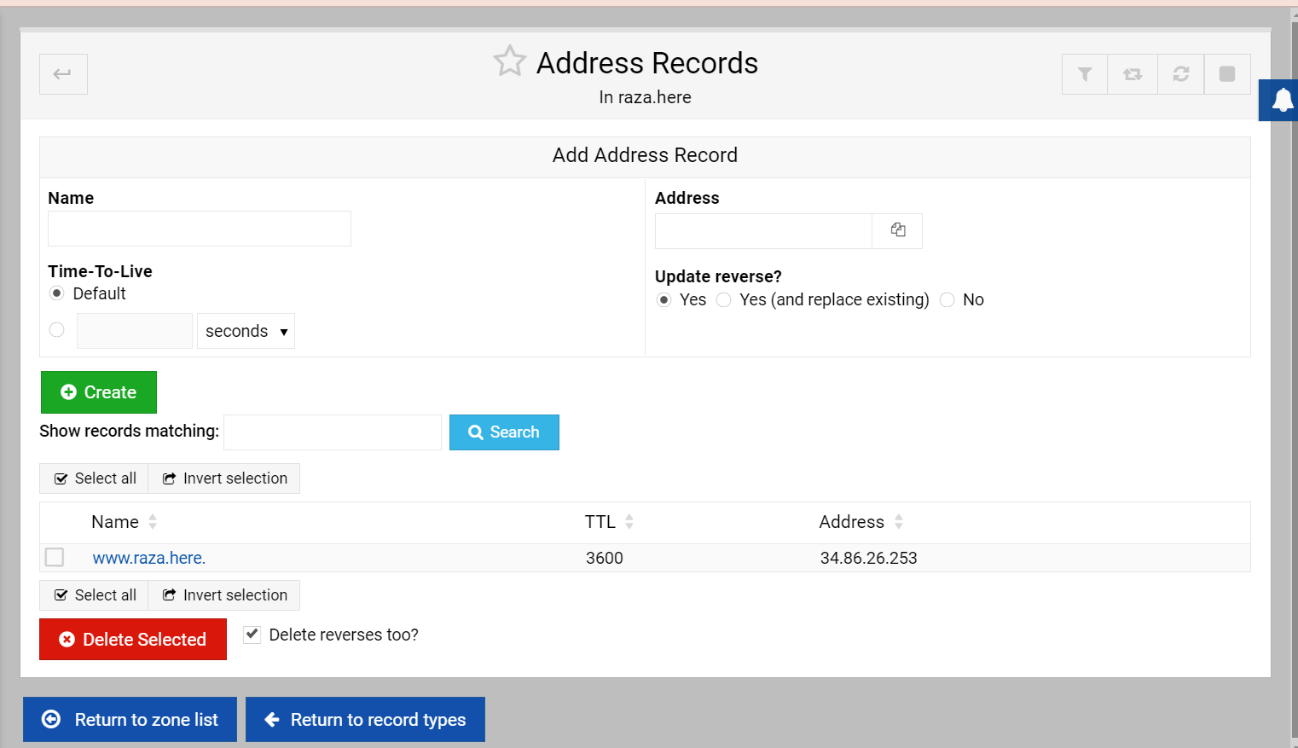
2. Now check that the new DNS settings is working correctly. Start a Command Prompt on the client and ping your new domain name:  
     
   **ping www.raza.here**  
   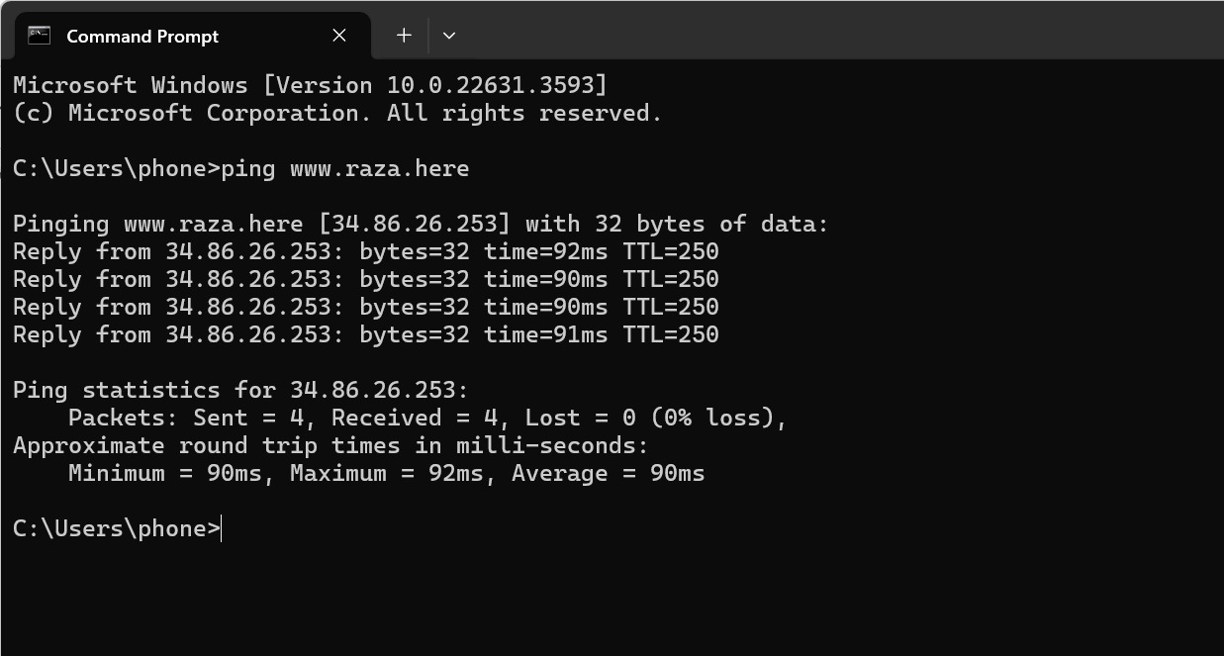

## Task 7 - Setting up a website for the new domain name on the Linux Server

1. Stop and Restart Apache  
   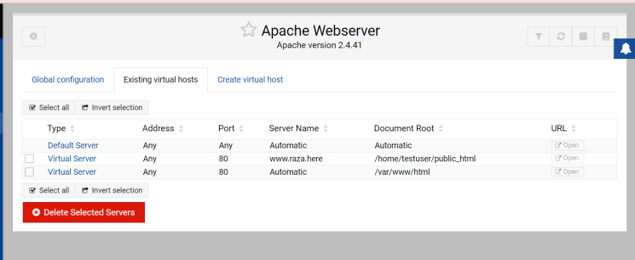

## Task 8 - Manipulating files on the Linux Server via Webmin

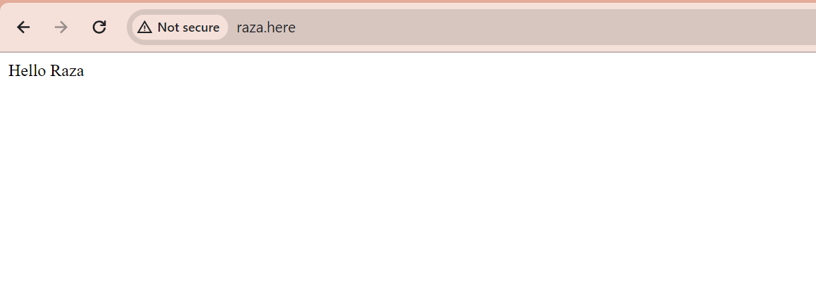

## Task 10 - Answer the following questions by researching on the web

1. List 3 web-based Linux administration software below (not including Webmin):  
   1. **a. Cockpit  
      b. Ajenti  
      c. ISPConfig**

What do the acronyms LAMP and WAMP stand for, in the context of web servers?  
  
**LAMP: Linux, Apache, MySQL, PHP  
WAMP: Windows, Apache, MySQL, PHP**